# Part 1: Importing and Indexing a Dataset

1. Upload the Austin Animal Center Outcomes data set into database ‘AAC’ into the MongoDB

1. Create Simple Index on the key ‘Breed’. Show Example Query. Use Explain function to verify the Index is used.

1. Create a compound index that will improve the performance of queries looking for breeds that have an ‘outcome_type’ of ‘Transfer’.

[Compound Index Creation]

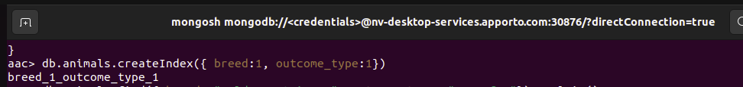

[Example Query with Explain Command demonstrating Index Usage]

*Notes*: Discovered my generic query didn’t use my new index…

So, out of curiosity I checked if Golden Retrievers were in the database…they aren’t!

So then I searched with something that was…

# Part 2: User Authentication

1. Create a new user account called ‘aacuser’

[User Creation]

[Screenshot of login commands for ‘admin’ user with db.runCommand({connectionStatus:1}]

[environment variable change]

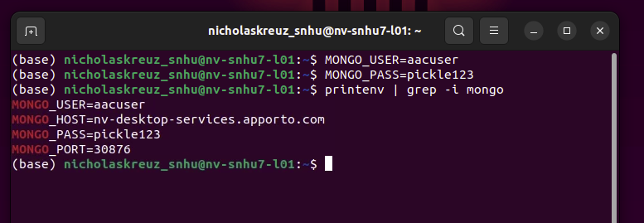

[Screenshot of login commands for ‘aacuser’ user with db.runCommand({connectionStatus:1}]

